[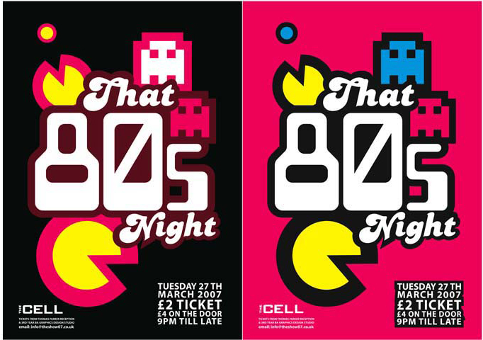](http://www.google.co.uk/url?sa=i&rct=j&q=&esrc=s&source=images&cd=&cad=rja&uact=8&ved=0CAcQjRw&url=http://pixshark.com/80s-poster-design.htm&ei=J-srVdWSG4L3Ov6bgKAM&psig=AFQjCNEFpQtuZF0Gc9LxU11s9II3G1jd3w&ust=1429027988195544)80's DJ MUSIC

BVCC

BVCC

SAT 27 TH JUNE 8.30PM TILL LATE

FANCY DRESS OPTIONAL

PRIZE FOR BEST

80's DJ MUSIC

SAT 27 TH JUNE 8.30PM TILL LATE

FANCY DRESS

OPTIONAL

80's DJ MUSIC

SAT 27 TH JUNE 8.30PM TILL LATE

FANCY DRESS OPTIONAL

PRIZE FOR BEST