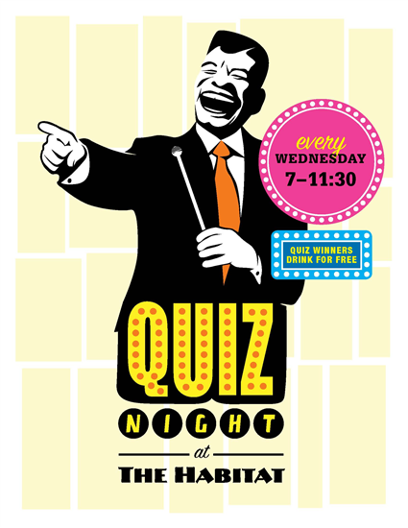

BOLTON VILLAS CC

Saturday

30th May

£1 to Play!

only

PLUS PLAY UR CARDS RIGHT!